# Installation

1. Python

Go to Softwareshop ,

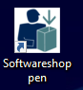

search ‘python’, choose ‘Python v3.9’

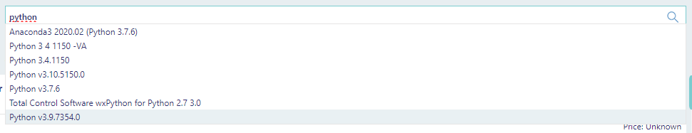

1. Visual Studio Code

Go to Softwareshop ,



search ‘visual studio code’ and install.

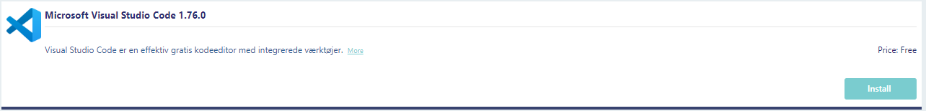

# Usage with ‘Visual Studio Code’

Copy the pipeline folder (L:\LovbeskyttetMapper\PRODSPN\ODiNe\GCMS targetted metabolomics python pipeline) to your local drive (desktop or downloads etc).

Open Visual Studio Code, upper left, click ‘File’, ‘Open Folder’, to locate your pipeline directory.

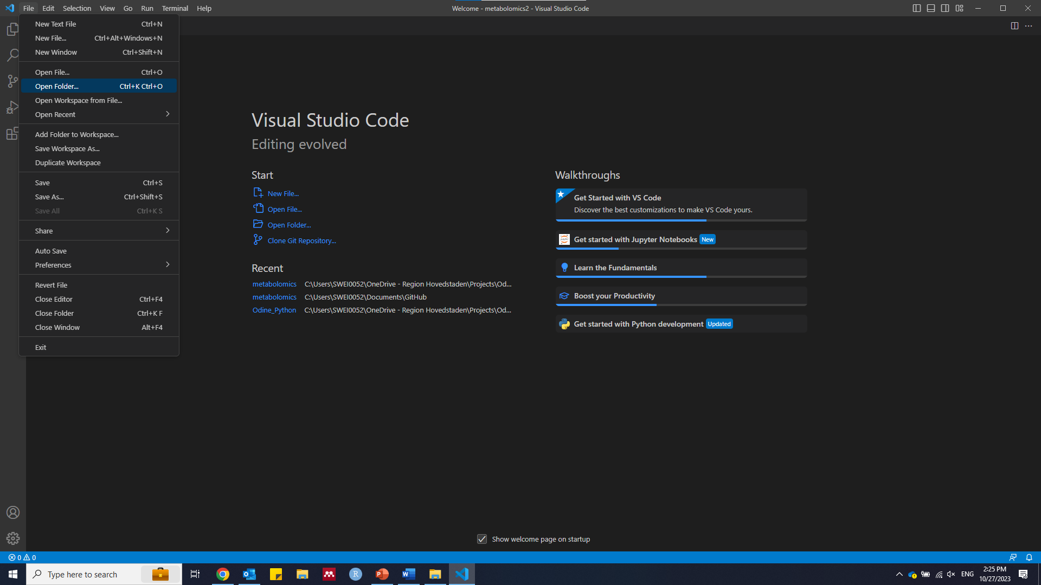

Then go the upper left, click ‘Extension’ sign  , search ‘Python’, click and install the first extension. Extensions make Visual Studio code user friendly, e.g. highlighting codes, virtual environment etc.

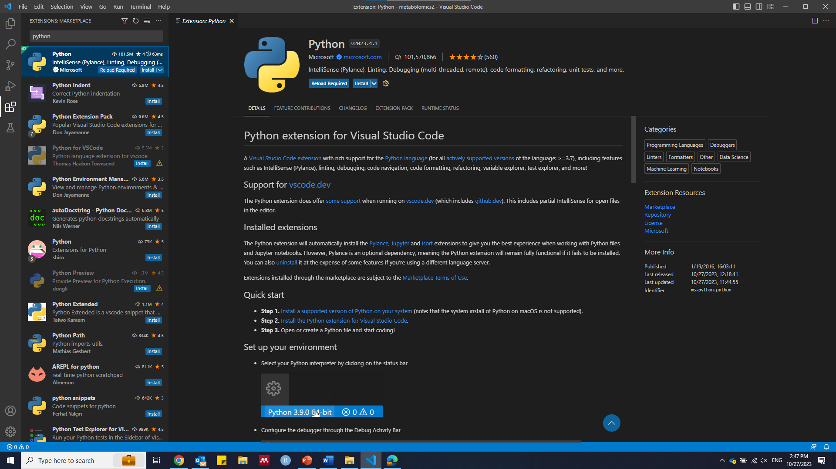

Then set up the python virtual environment, click lower left settings , then click ‘Command Palette’

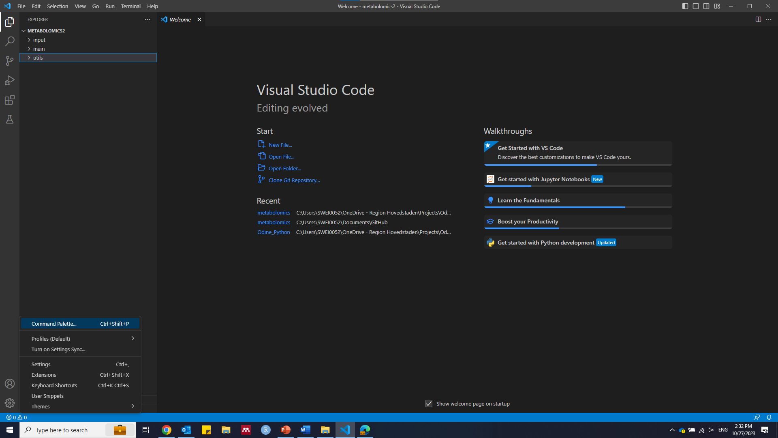

search ‘>create environment’ and choose “Venv Creates a ‘.venv’ ……. “, choose your installed python. This will create an isolated virtual environment, all needed python packages/modules will be installed in the environment folder. keep ‘>’ in the search box, it indicates search for commands.

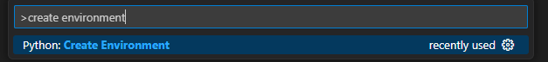

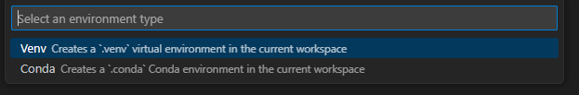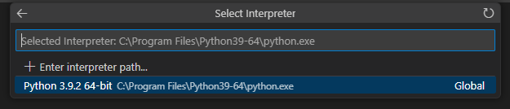

Then set up the python interpreter, click lower left settings , then click ‘Command Palette’ and search ‘>python interpreter’, choose the python located inside the ‘.venv’.

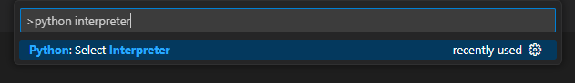

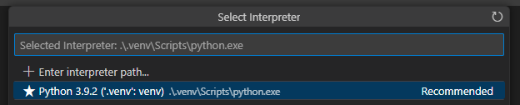

Go to pipeline directory by clicking ‘Explorer’ sign 

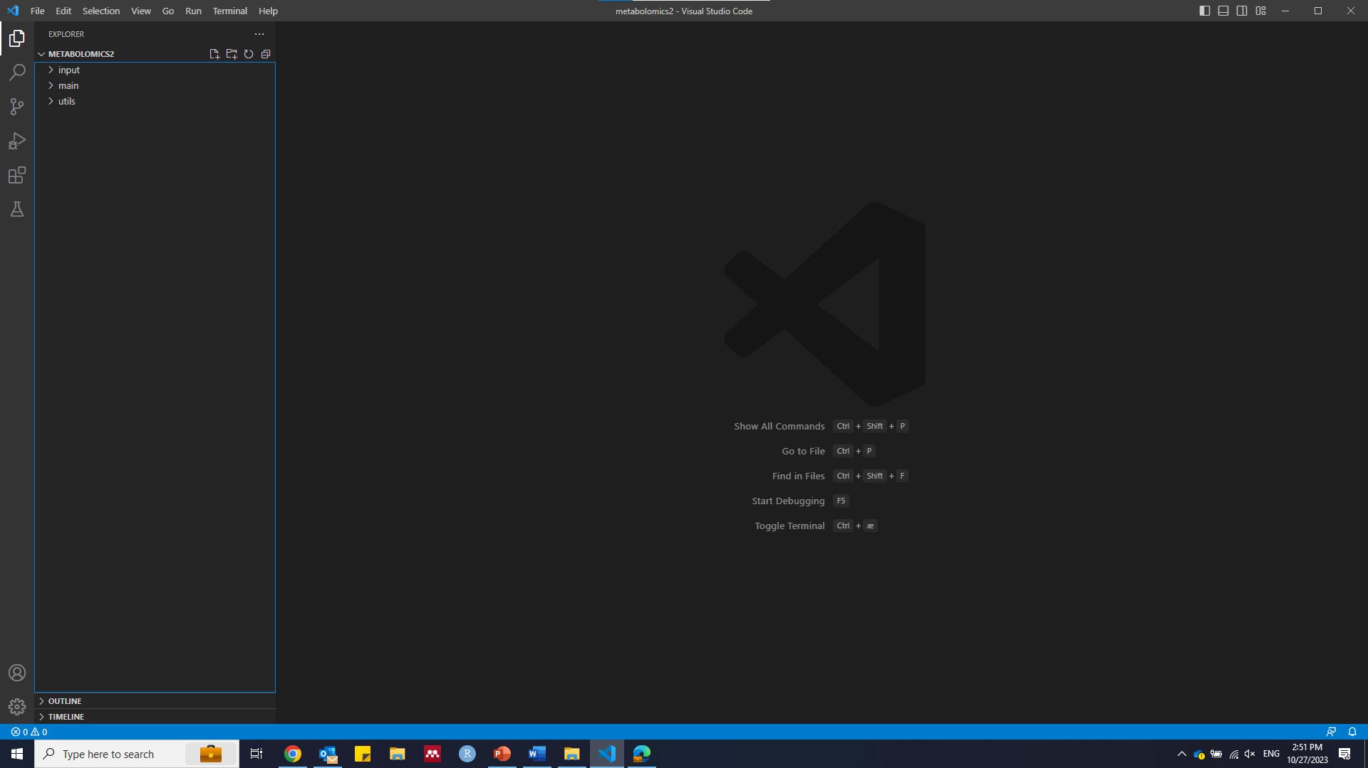

Single click the ‘packages_installation.py to preview the file, click  to install all needed packages.

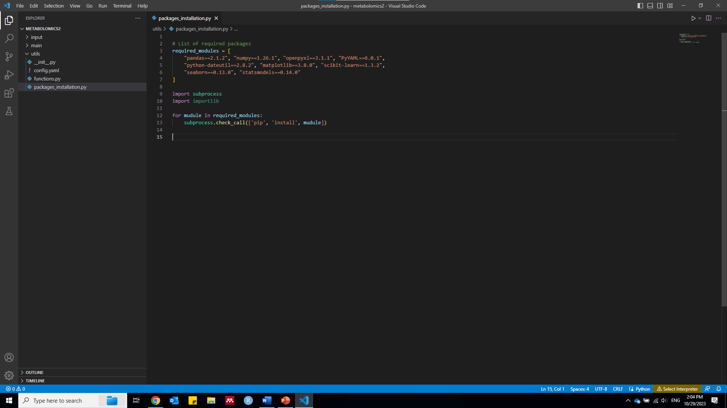

Click ‘config.yaml’ file to configure your parameters. Put your single to-be-analyzed table (e.g. excel or csv) in the ‘input’ directory.

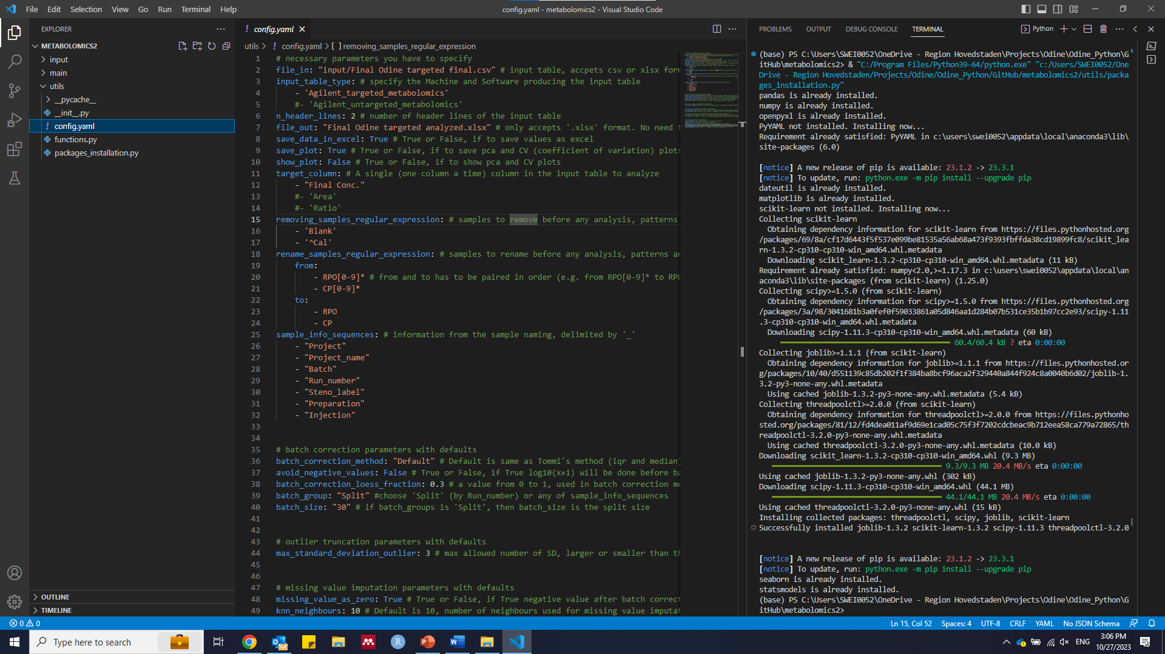

Run ‘main/ GCMS_targeted_metabolomics_V1.py’. Your analyzed data will be in ‘input/output’.

